

***Financial Grant Application***

Kyoshi Andrew Roberts Foundation

P.O. Box 378. Mt.Evelyn. 3796

0409211870 Heather Roberts (Director)

Date:

|  |  |  |  |
| --- | --- | --- | --- |
| **Patient Details** | | | |
| Name: | | | Date of Birth: |
| Address: | | | Contact Number: |
| Email: |  | | |
| Carer Name (if applicable): | | | Carers Contact Number |
| Carers email: | |  | |
| **Medical Details (please attach current medical statement from Doctor / Surgeon)** | | | |
| Date of initial diagnosis: | | | |
| Diagnosis (tumour / grade): | | | |
| Treatment: | | | |
| Prognosis: | | | |
| **Bank Account Details** | | | |
| Bank Name: | | | BSB: |
| Account Name: | | | Account Number: |
|  | | |  |
| Are you requiring any other assistance (counselling and support group, home based services etc):  Signature: | | | |

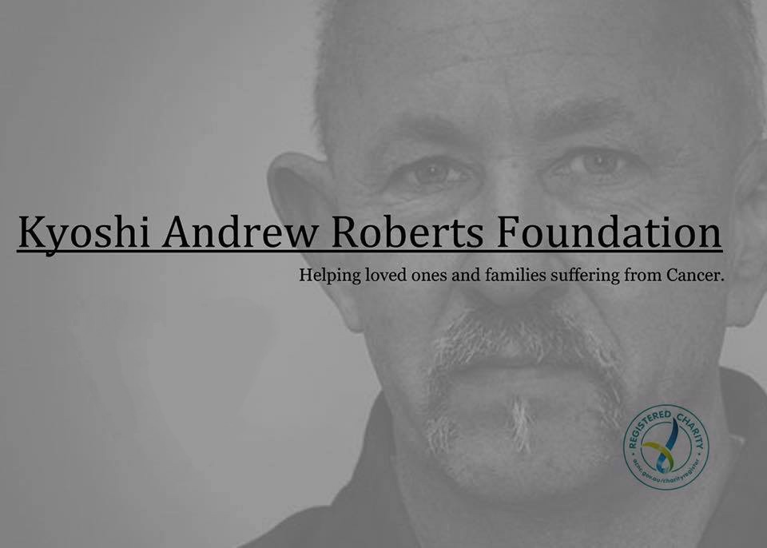

[heatherroberts135@yahoo.com.au](mailto:heatherroberts135@yahoo.com.au)

ABN: 73 434 290 304

Brain Cancer Support for everyone